Inspection Report

Club Cortile HOA
Property Address: 2809 Club Cortile Cir. Kissimmee Fl 34746
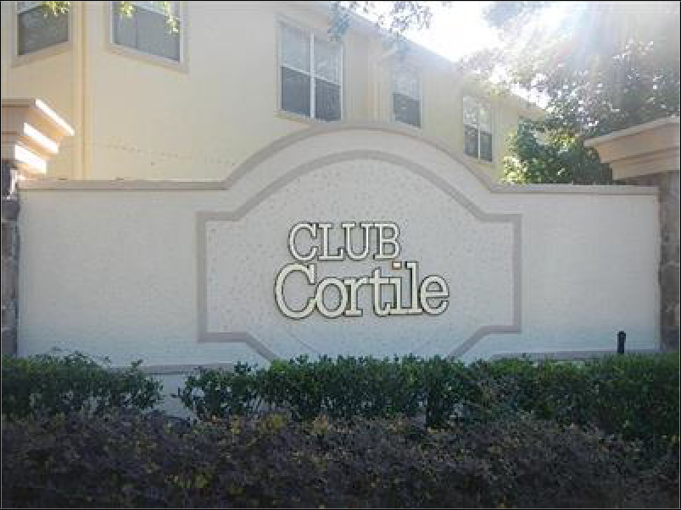

CARR Inspection Services, Inc

William Carr Jr. PE, CGC 815 Cura Ct.
Oakland, Fl. 34787
407.473.2971

Table of Contents

Cover Page 0
Table of Contents 0
Intro Page 0
1 Exterior 5
Invoice 0
Agreement 0

Date: 5/29/2019 | Time: |  | Report ID: 20190529S
Property:  2809 Club Cortile Cir. Kissimmee Fl 34746 | Customer:  Club Cortile | HOA | Real Estate Professional:

Comment Key or Definitions

The following definitions of comment descriptions represent this inspection report. All comments by the inspector should be considered before purchasing this building. Any recommendations by the inspector to repair or replace suggests a second opinion or further inspection by a qualified contractor. All costs associated with further inspection fees and repair or replacement of item, component or unit should be considered before you purchase the property.

Inspected (IN) = I visually observed the item, component or unit and if no other comments were made then it appeared to be functioning as intended allowing for normal wear and tear.

Not Inspected (NI)= I did not inspect this item, component or unit and made no representations of whether or not it was functioning as intended and will state a reason for not inspecting.

Not Present (NP) = This item, component or unit is not in this building or building.

Repair or Replace (RR) = The item, component or unit is not functioning as intended, or needs further inspection by a qualified contractor. Items, components or units that can be repaired to satisfactory condition may not need replacement.

In Attendance:
Customer
Type of building:
Condominium
Approximate age of building:
13 Years

Temperature:
Over 85 (F)

Weather:
Clear

Ground/Soil surface condition:
Dry

Rain in last 3 days:
No

1. Exterior

IN NI NP RR
1.0 | WINDOWS | X
IN NI NP RR
IN=Inspected, NI=Not Inspected, NP=Not Present, RR=Repair or Replace

Comments:
1.0 This report is a Specific Purpose inspection related to the review and reporting of 28 windows [as per scope] and providing an opinion of condition and remedy of all 116 windows classified as "Metal, Fire Rated". Further, inspector will provide a repair procedure that may be authored by the window manufacture.

The basic scope of services is to inspect, photo document,report finding, investigate the reason for this type of window with the county and provide a repair procedure. My field investigation dates were 5/23 and 25/2019. A two [2] part spread sheet has been submitted via email identifying actions as follows: No Action [no repair needed], Minor repair [limited rust removal and paint repair], Repair [moderate to substantial rust repair, possible metal enhancement and paint and Replacement [my opinion that rusted areas can not be field repaired]. All photos for the investigation of the 28 units [front windows] are contained herein. All 118 window photos will be provided, in order via email[s].

The 28 front window units are as follows:

Building 1: 2878A, 2878B, 2880A, 2880B, 2876A, 2876B, 2882A, 2882B Building 2: 2856A, 2856B, 2858A, 2858B, 2860A, 2860B, 2862A, 2862B Building 3: 2798A, 2798B, 2800A, 2800B
Building 4: 2720A, 2720B, 2722A, 2722B, 2724A, 2724B, 2726A, 2726B

Osceola Co Building Dept. verbally responded to my request to define why these windows are fire rated, with the following response: The rated window[s] were required by both the IBC { International Building Code} and the Fire Safety Code because the placement of the window is within 10' of the egress travel path to escape the structure, under the Commercial Section [over 4 units to a structure]. The 45 minute rated window is also a requirement on the end units because the 2nd floor stair case is within 10' of the second floor window and of course the first floor window.

I'm waiting for a repair procedure from the manufacture however I do have a 3rd party repair procedure in case of no response. I have sent the manufacture photos and the one response concerning repair[s] to the

sash is, they can not be removed without disassembly of the side frame and thus possibly breaching the seal which is apart of the fire rating. It appears that any sash repairs will have to be accomplished inplace.

The cause of the rust is blocked weep slots. It is evident the weeps are blocked by the stucco banding and or masonry caulk which is painted. This caused water to "sit" in the lower channel and because the rated window is metal, the corners rusted. Additionally, no matter the procedure to repair, the weeps must be opened of a hole driller on both sides to evacuate water from inside the channel. I believe 2 windows reviewed were found to have had this done and were in better condition than most all the other windows that need repair/replacement.

All infrared photos showed no moisture intrusion.

Generic Repair Procedure [Not provided by the window manufacture]:

Scrub partially rusted metal areas with a wire brush to remove flakes and powdery surface rust, more severe areas will need a wire brush wheel attached to a drill. Protect the in frame glass from being scratched. Clean area from dust, then apply a primer that adheres to rusted surfaces, such as Krylon Rust Tough or Rust-Oleum. For locations that are very badly rusted, areas not reachable to scrape clean or too thin to clean thoroughly, use a product like Rust-Oleum Rust Reformer, which soaks into the rust and changes it into a non-rusting, paintable surface. LET DRY, completely. Once dry, paint over treated areas, 2 coats [1st application light, let dry]. The sashes are likely to need Rust-Oleum Rust Reformer.

IMPORTANT NOTE: Since the existing weeps are blocked, a 1/8" dia. hole will need to be drilled in every corner, at or very need the the stucco interface with the bottom window metal.
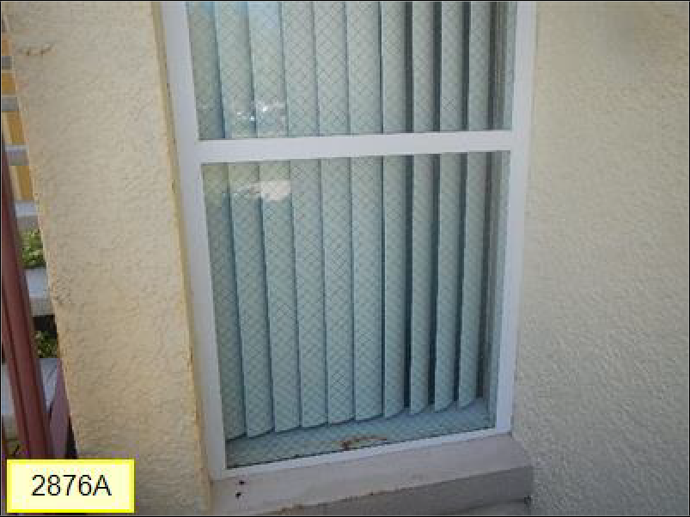
1.0 Picture 1
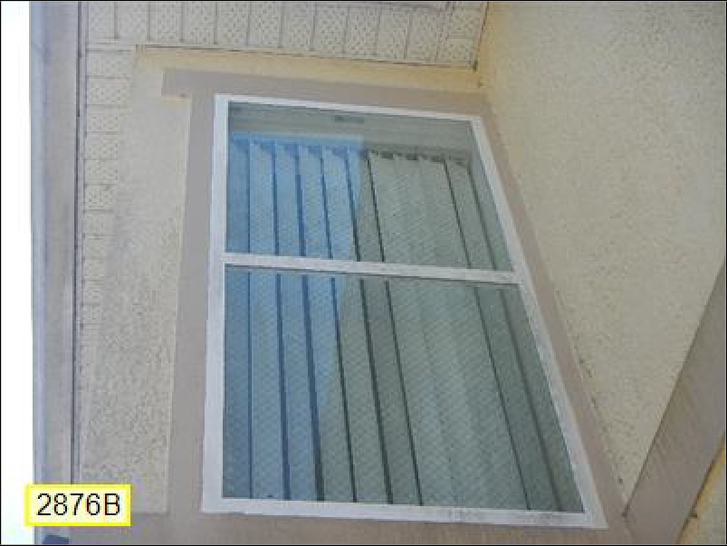
1.0 Picture 2

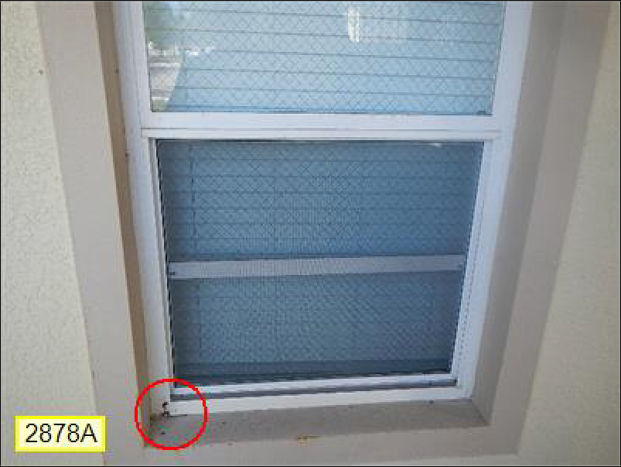
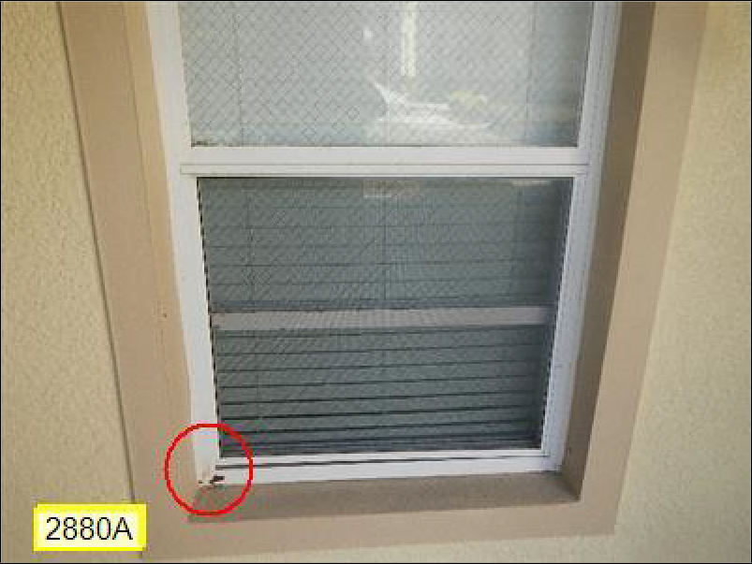
1.0 Picture 3
1.0 Picture 4

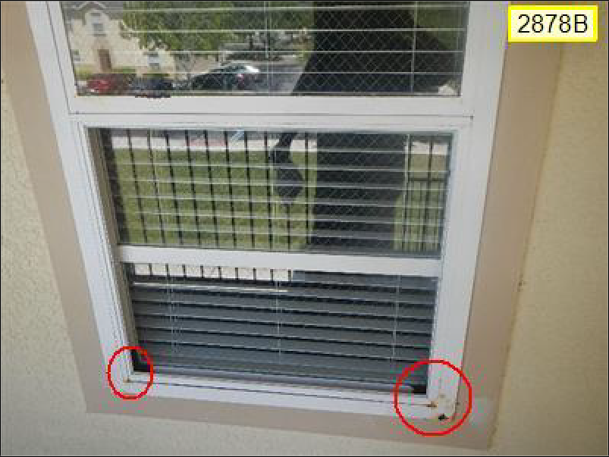
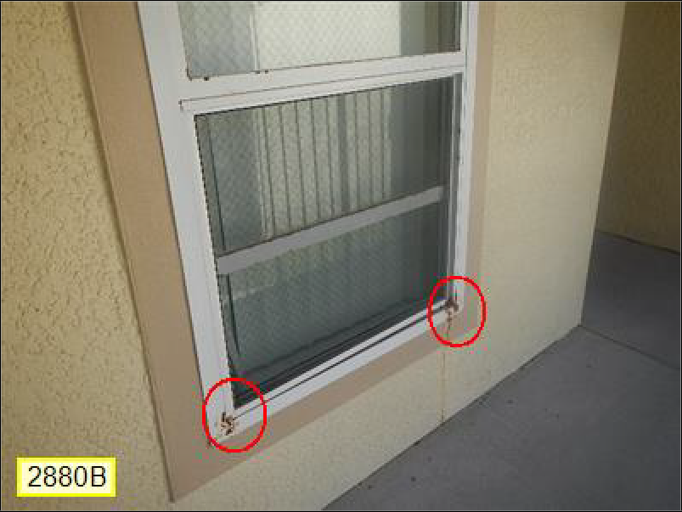
1.0 Picture 5
1.0 Picture 6

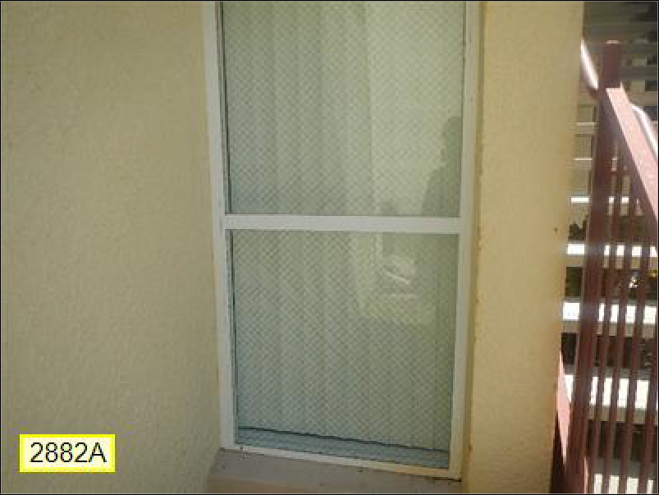
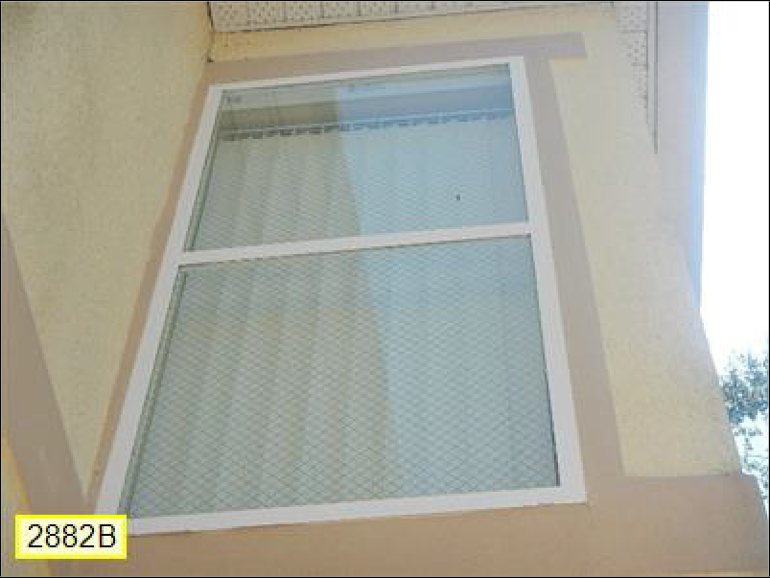
1.0 Picture 7
1.0 Picture 8

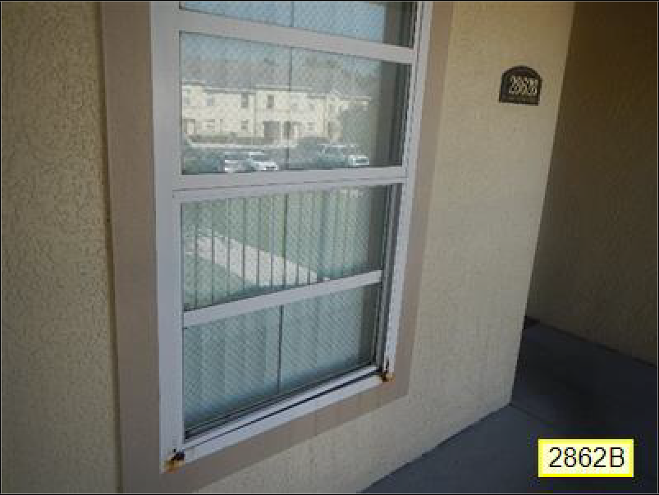
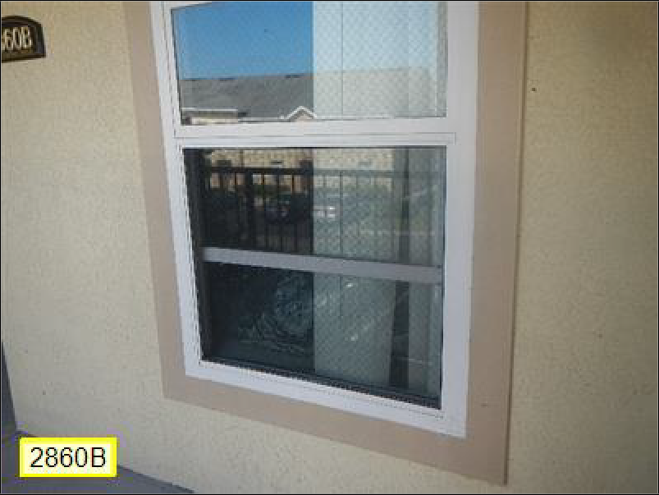
1.0 Picture 9
1.0 Picture 10

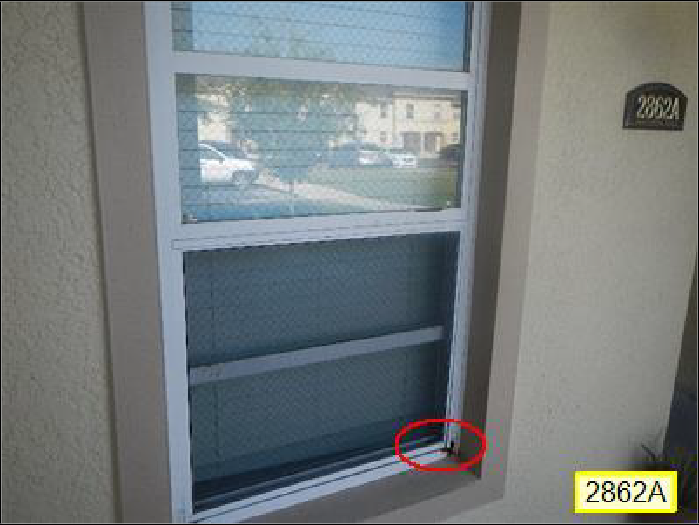
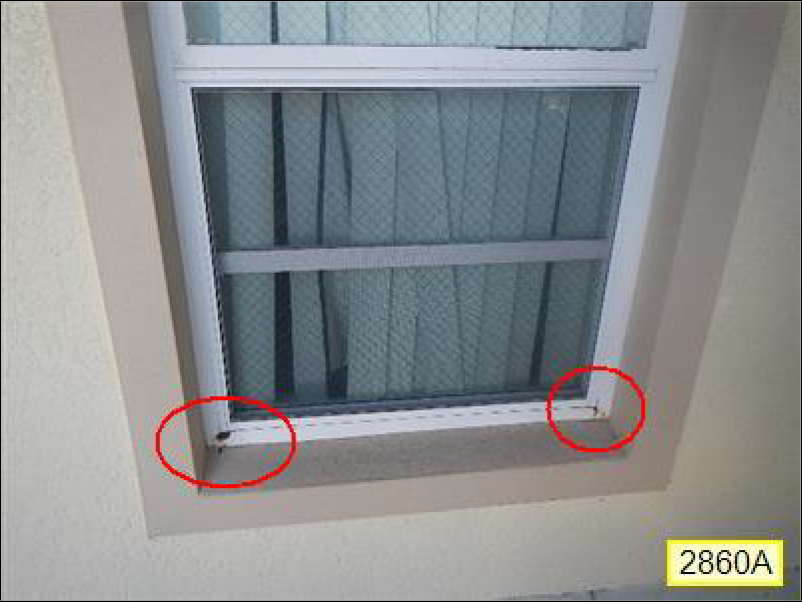
1.0 Picture 11
1.0 Picture 12

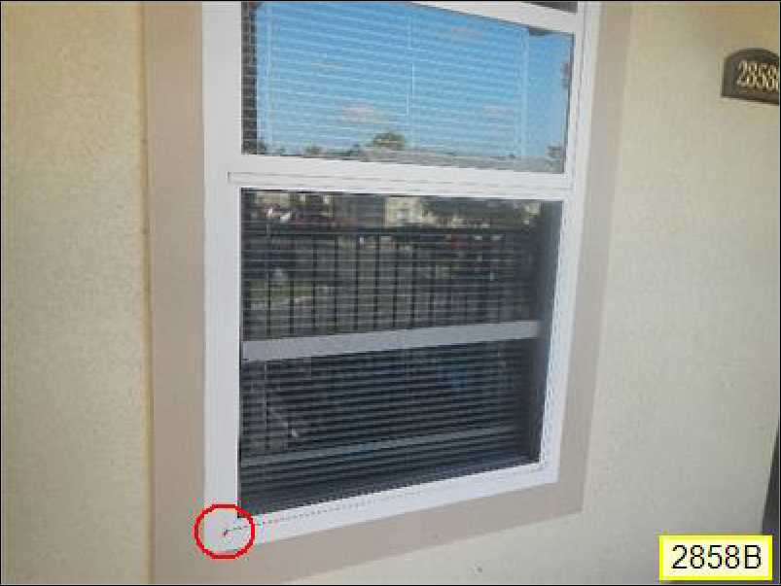
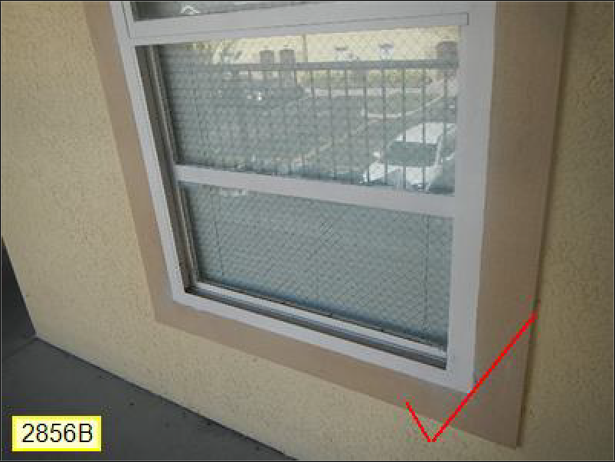
1.0 Picture 13
1.0 Picture 14

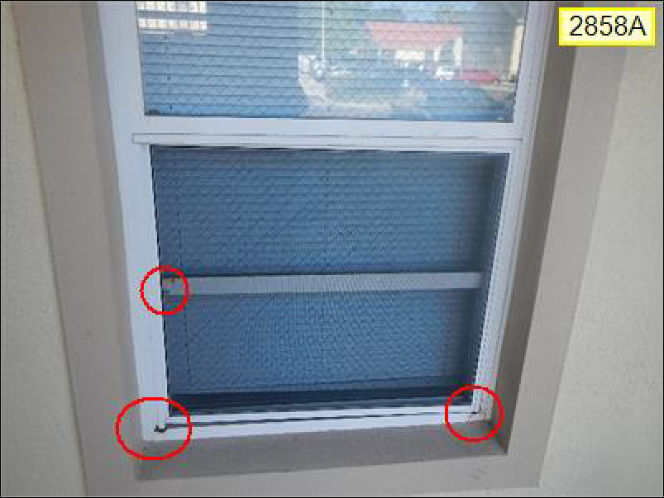
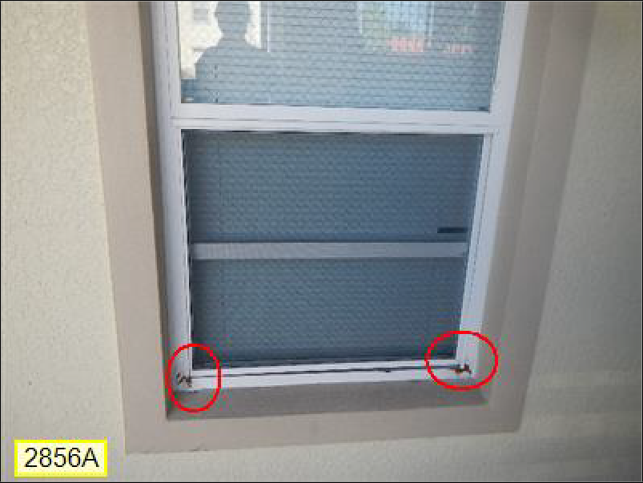
1.0 Picture 15
1.0 Picture 16

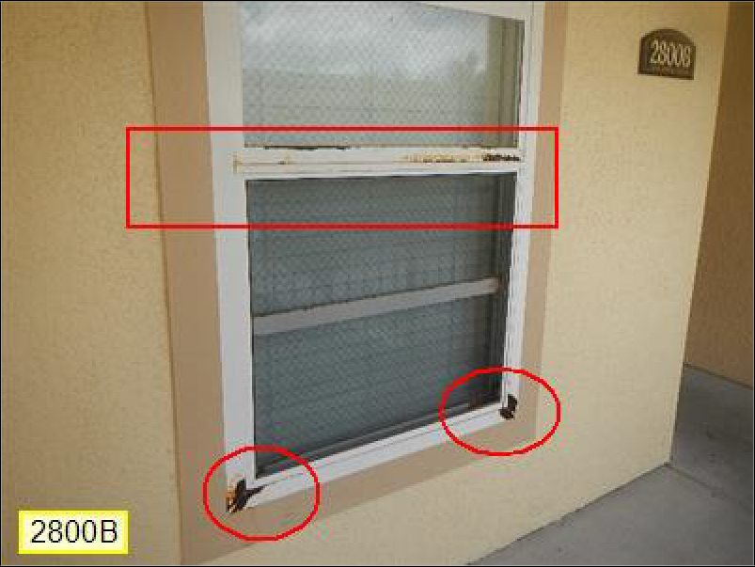
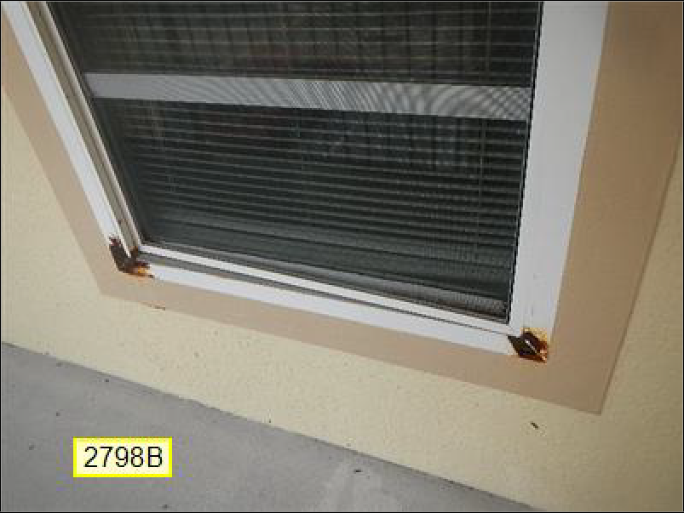
1.0 Picture 17
1.0 Picture 18

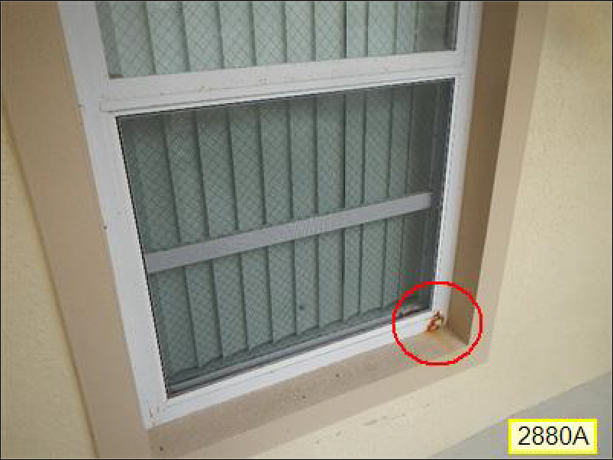
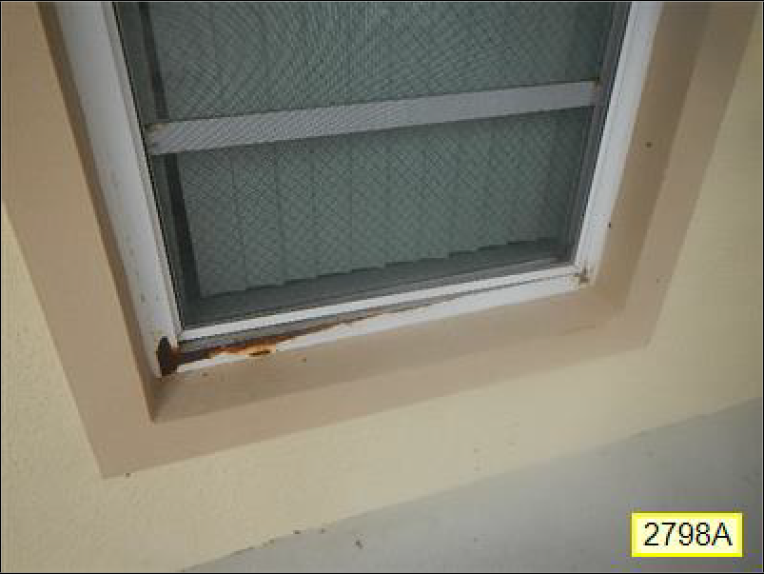
1.0 Picture 19
1.0 Picture 20

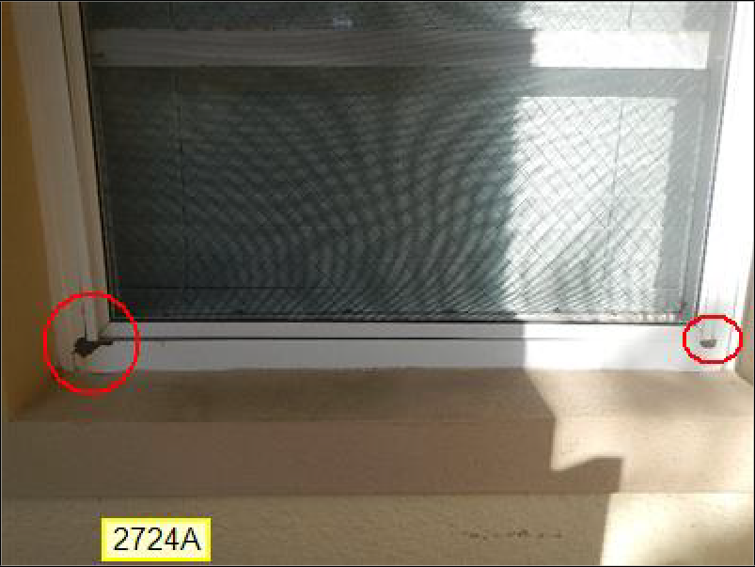
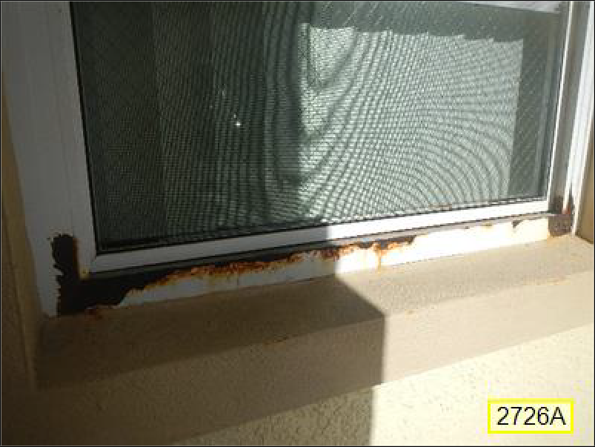
1.0 Picture 21
1.0 Picture 22

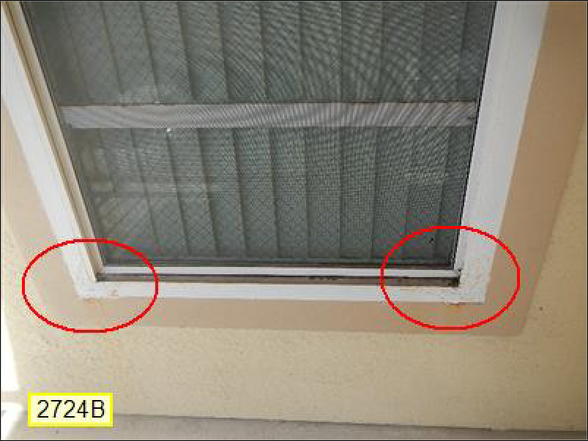
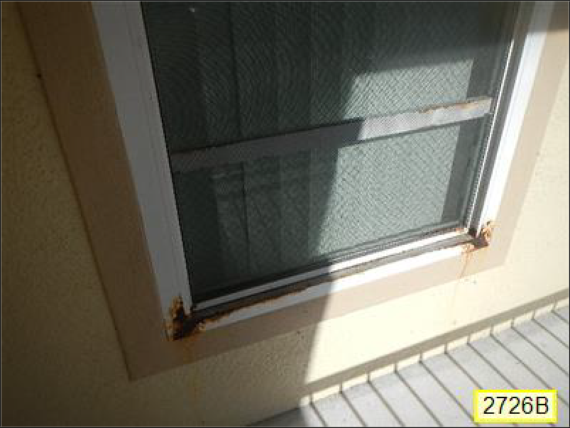
1.0 Picture 23
1.0 Picture 24

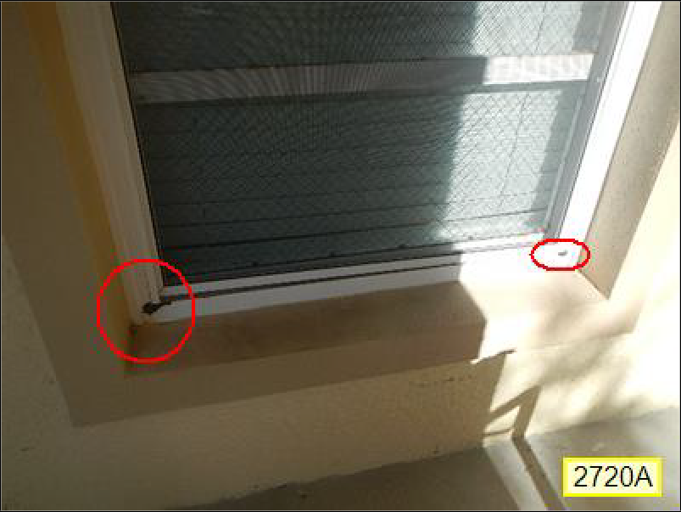
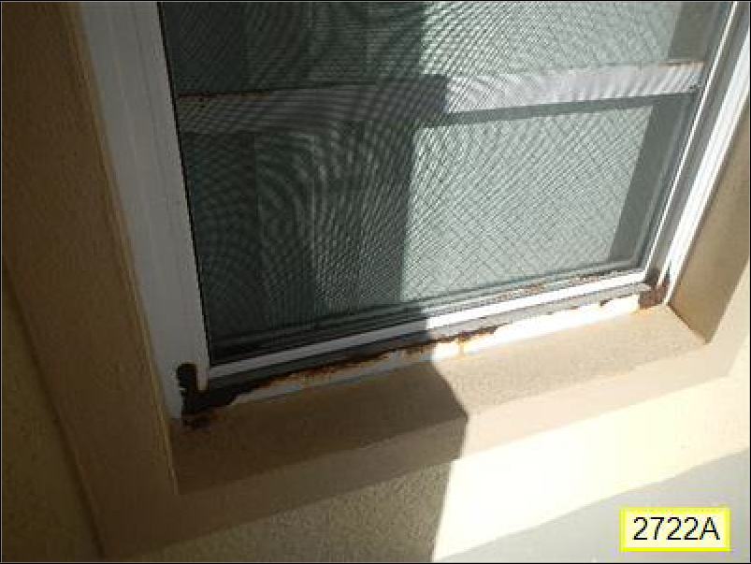
1.0 Picture 25
1.0 Picture 26

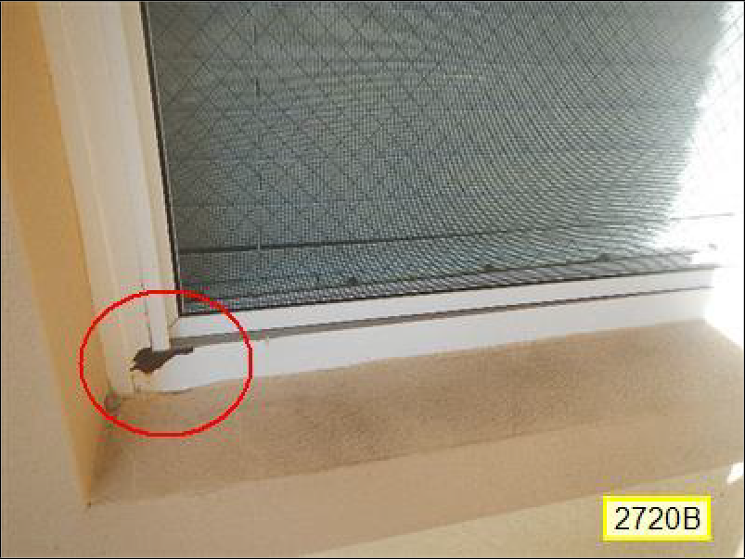
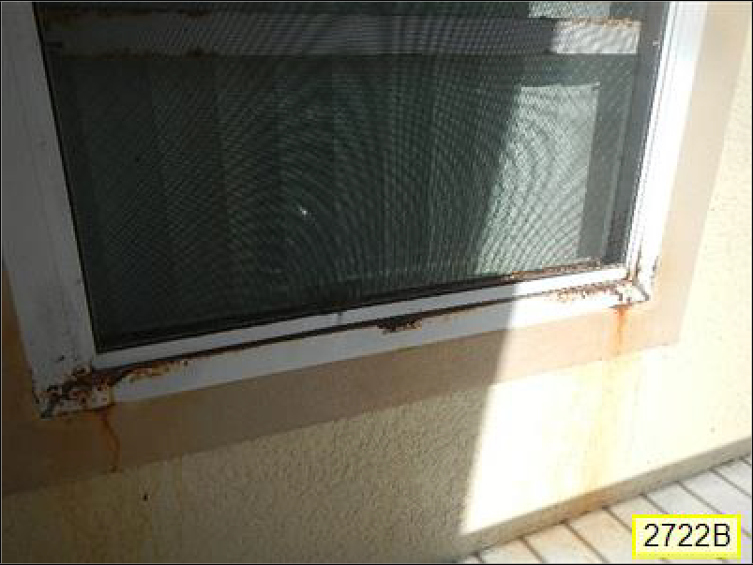
1.0 Picture 27
1.0 Picture 28

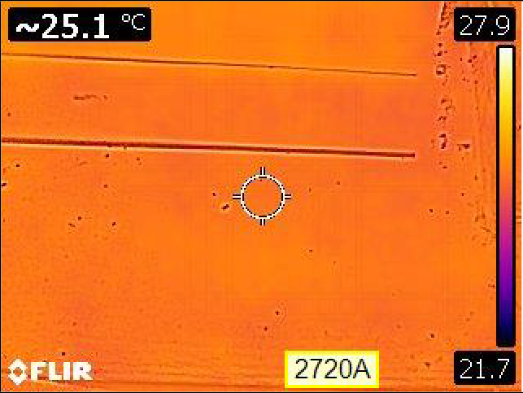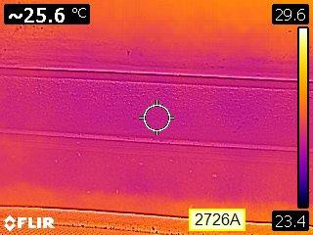
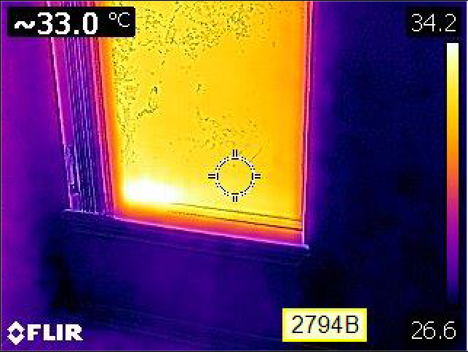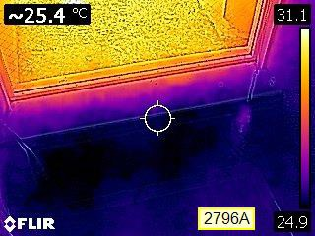1.0 Picture 29 1.0 Picture 30
1.0 Picture 31 1.0 Picture 32
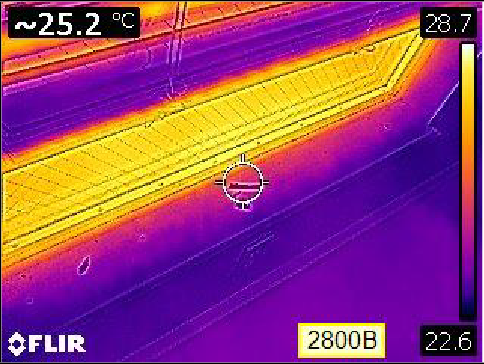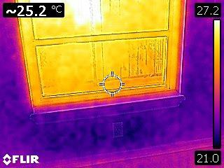
1.0 Picture 33 1.0 Picture 34

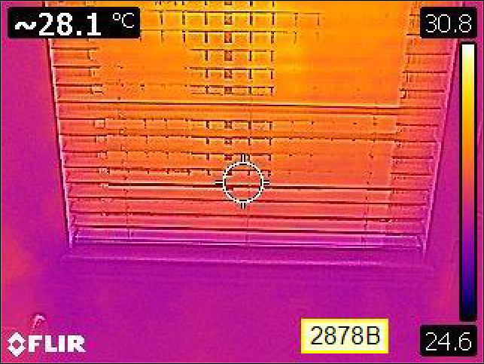
1.0 Picture 35

Prepared Using HomeGauge http://www.HomeGauge.com : Licensed To CARR Inspection Services, Inc

CARR Inspection Services, Inc 815 Cura Ct.
Oakland, Fl. 34787
407.473.2971
Inspected By: William Carr Jr. PE, CGC
INVOICE

Inspection Date: 5/29/2019
Report ID: 20190529S

Customer Info: | Inspection Property:
Club Cortile HOA  Customer's Real Estate Professional: | 2809 Club Cortile Cir. Kissimmee Fl 34746

Inspection Fee:

Service Price Amount Sub-Total
Commercial Inspection Contract [Windows] 3628.00 1 3628.00
Tax $0.00 Total Price $3628.00

Payment Method: Check Payment Status: Pending Note:

Inspection Agreement

This inspection was performed in accordance with and under the terms of a Pre-Inspection Agreement. The agreement was signed and agreed upon before the preparation of this report and a signed copy of the agreement is available upon request. An unsigned copy of the agreement may be attached to this report for your information or it may also be available on the company web site.

